Region F Representative Application

The position of a PASC Region Representative holds many opportunities for the school, student council, and the individual student. Many opportunities are provided for leadership training, travel, and development of human relations skills. With these opportunities come time commitment and leadership responsibilities. (Please read the Region Rep. Job Description)

The election of the Representative takes place during the Region Conference every two years. The school of the nominee must not have held a PASC regional representative seat during the past two terms. Even though students are running individually now, each school may only submit one candidate for the election.

The elected student must attend the January, March, and summer PASC Board meetings, a PASC Summer Leadership Camp, State Conferences, Region 2 Conferences. at least one National Conference and Region Board meetings. The student selected by must be in grades 9 or 10 in order to fulfill the two-year ter - Summer 2021 and run until Summer 2023.

General Information Request:

Name of Applicant Email:

Grade of Applicant

Name of School: County:

School Address: City: Zip:

School Phone: School Fax:

SC Advisor Name: Email:

Principal Name:

Required Signatures:

SC Advisor: Date:

Principal: Date:

Application Due Date: January 15, 2021

PASC
Pennsylvania Association
of Student Councils
Region
F

Send Completed Application to: (preferred method: scan and attach in email)

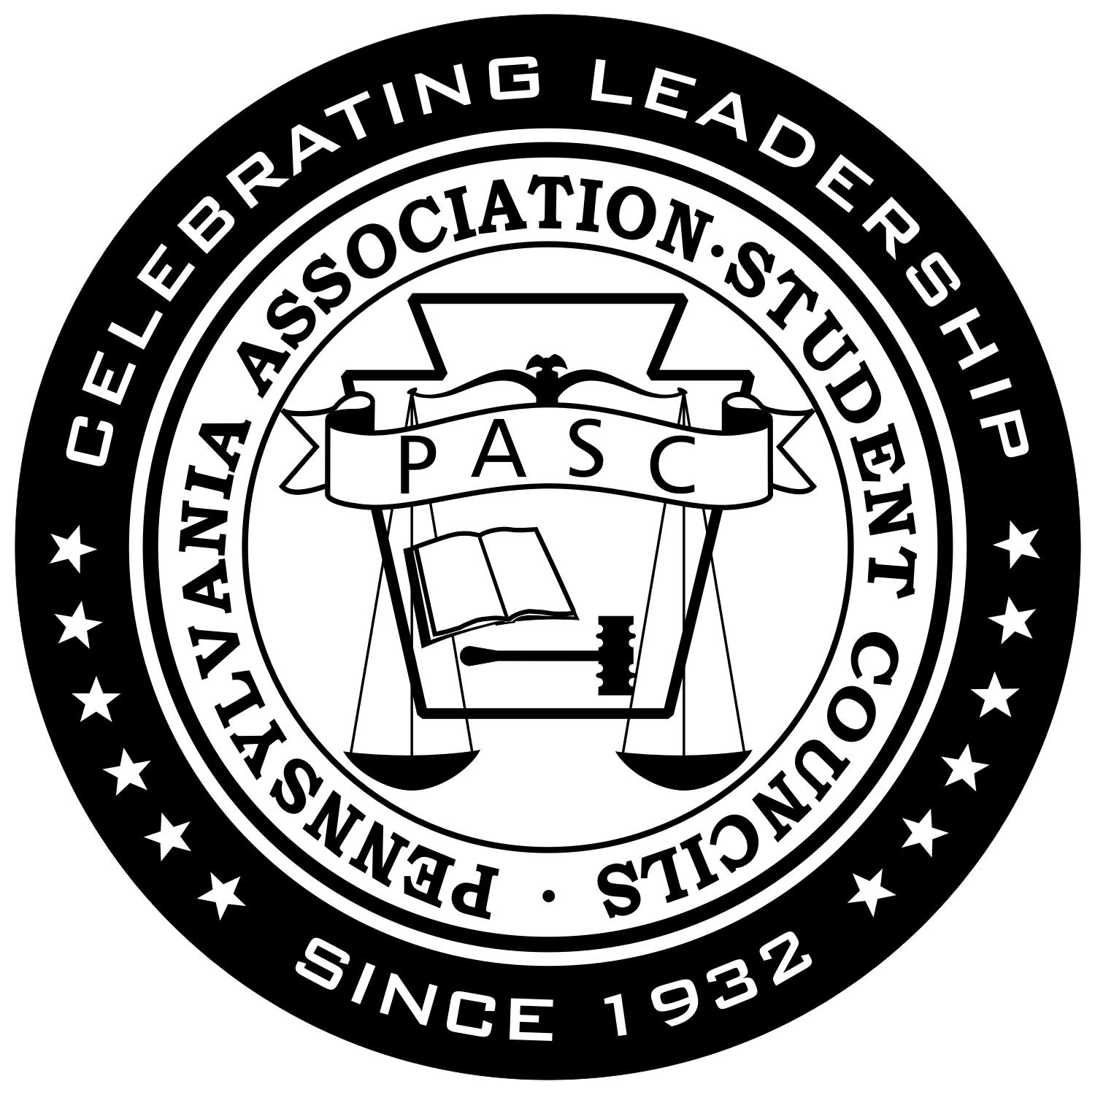
Micala Wool, Region F Interim Director
Bermudian Springs High School
7335 Carlisle Pike
York Springs, PA 17372

Ph: 717-528-4113

Regionfdirector@pasc.net

